Bus Management Database — Database Design

Scenario Topic: Bus Management Database

Scenario

This database models the day-to-day operations of a bus network. Each bus operates on a fixed route with a defined start position and termination stop and is assigned a unique Bus ID and bus number. Buses are also associated with a specific bus model, which records physical details such as height, width, number of levels, and seating capacity. Because different buses can share the same model, and a model can be used across multiple buses, this relationship is represented as a many-to-many link through a junction table.

Each driver is assigned a unique Driver ID and is linked to exactly one timetable, which specifies their shift times, contracted hours per week, allocated breaks, and the days they work. Drivers are also bound to a single contract at any given time, which records their salary, holiday entitlement, and the start and end years of the contract. A driver can be either full-time or part-time, but not both simultaneously. Full-time drivers are entitled to bonuses and perks and work between 24 and 40 hours per week, while part-time drivers have flexible working hours ranging from 1 to 23 hours per week.

Passengers are required to pay a fare to board a bus. Each payment record stores the fare amount and the type of pass used. The database distinguishes between two passenger types: children and adults. Children may pay using an Oyster card or cash, whereas adults have a wider range of options including debit card, credit card, contactless payment, and PayPal. This is enforced as a mandatory XOR constraint, meaning every passenger must be classified as either a child or an adult.

Example Queries

- How many contracts can each driver have?
- Which form of payment can the adult use to pay for the bus?
- Which form of payment can a child use to pay for the bus?
- Fewest number of hours for a part time driver?
- Most number of hours a full-time driver can work?
- Can a child use a debit card to pay for the bus fare?

Entity Relationship Diagram

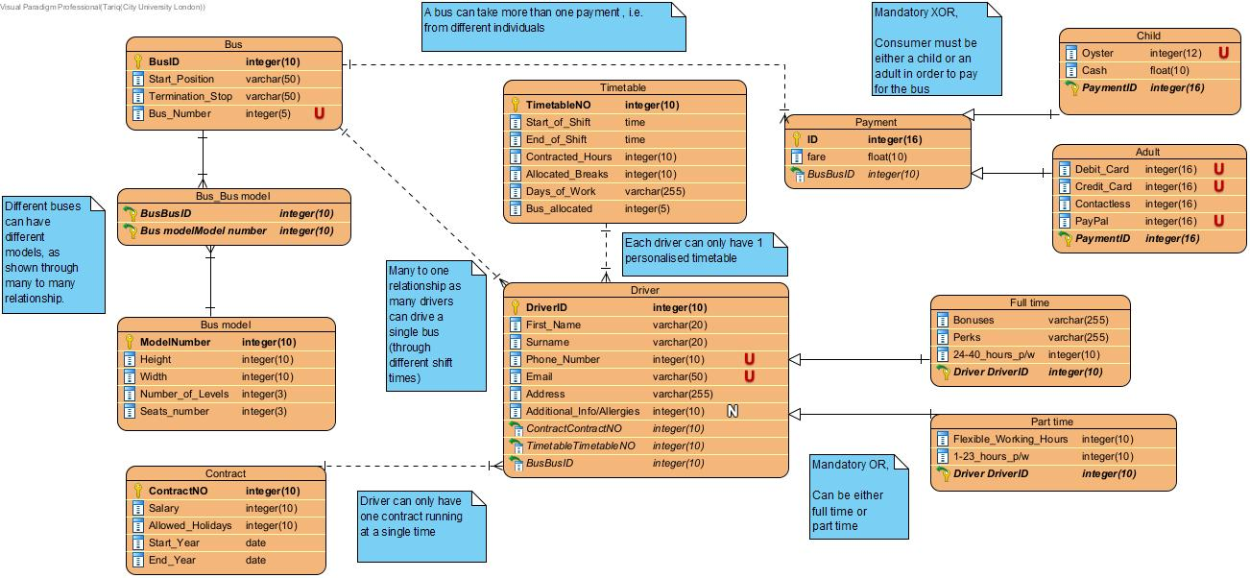

Relational Model Tables

Relational table specification
Table name: Bus
Attributes
BusID
Start_Position
Termination_Stop
Bus_Number
PRIMARY KEY (BusID)
FOREIGN KEY (BusBusID) REFERENCES BUS (BusID)
FOREIGN KEY (Bus modelModel number) REFERENCES Bus model (ModelNumber)

Relational table specification
Table name: Bus model
Attributes
ModelNumber
Height
Width
Number of levels
Seats number
PRIMARY KEY (ModelNumber)
FOREIGN KEY (BusBusID) REFERENCES Bus (BusID)
FOREIGN KEY (Bus modelModel number) REFERENCES Bus model (ModelNumber)

Relational table specification
Table name: Contract
Attributes
ContractNO
Salary
Allowed_Holidays
Start_Year
End_Year
PRIMARY KEY (ContractNO)

Relational table specification
Table name: Timetable
Attributes
TimetableNO
Start_of_Shift
End_of_Shift
Contracted_Hours
Allocated_Breaks
Days_of_Work
Bus_allocated
PRIMARY KEY (TimetableNO)

Relational table specification
Table name: Driver
Attributes
DriverID
First_Name
Surname
Phone_Number
Email
Address
Additional_info/Allergies
PRIMARY KEY (DriverID)
FOREIGN KEY (ContractContractNO) REFERENCES Contract (ContractNO)
FOREIGN KEY (TimetableTimetableNO) REFERENCES Timetable (TimetableNO)
FOREIGN KEY (BusBusID) REFERENCES Bus (BusID)

Relational table specification
Table name: Full time (sub class)
Attributes
Bonuses
Perks
24-40_hours_p/w
PRIMARY KEY ()
FOREIGN KEY (Driver DriverID) REFERENCES Driver (DriverID)

Relational table specification
Table name: Part time (sub class)
Attributes
Flexible_Working_Hours
1-23_hours_p/w
PRIMARY KEY ()
FOREIGN KEY (Driver DriverID) REFERENCES Driver (DriverID)

Relational table specification
Table name: Payment
Attributes
ID
fare
PRIMARY KEY (ID)
FOREIGN KEY (BusBusID) REFERENCES Bus (BusID)

Relational table specification
Table name: Child (sub class)
Attributes
Oyster
Cash
PRIMARY KEY ()
FOREIGN KEY (PaymentID) REFERENCES Paymemt (ID)

Relational table specification
Table name: Adult (sub class)
Attributes
Debit_Card
Credit_Card
Contactless
PayPal
PRIMARY KEY ()
FOREIGN KEY (PaymentID) REFERENCES Payment (ID)

